ABSTRACT

Project Title : Radiant Reservation System

Project Description :

Radiant Reservation System (RRS), A Integrated Software for tour operating companies which comprises all the tour industry related and especially made keeping view of South Africa, Tanzania and other East African countries. RRS helps the, Tour Operating Companies, manage their Customers, Hotels, Vehicles and Agents and makes all operations of the tour company easy and accurate.

The main Modules in the application are (1) Admin Module handles the entire Master forms such as Staff Master, Agent Master, activity master and Location Master, user master etc. (2) Hotel Module consists of Hotel master it has all the details i.e. name of the hotel, hotel address, contact person details, no. of rooms in hotel and facilities available in that hotel. Hotel tariff according to the room type, bed type, sharing type, seasons wise, age group wise i.e. adult, junior, child, corporate and rake rate wise. Hotel group wise discounts will be accommodated. (3) Itinerary Module has both Fixed touring packages, it schedule and custom itineraries in this reserving of hotels and vehicles etc has been handled. In this itinerary Total package price and adult price, child price breakups will come automatically. Customer master screen also included in this module. Customer contact information, group details, breakups of individual arrivals and departures in the group, customer code generation and tracking will be there. Grouping can be done customers wise; Guide and drivers allocation will be done. (4) Vehicle module – It has Vehicle Master it capture Vehicle details i.e. Vehicle type, vehicle own or hired, vehicle registration no, Vehicle chassis No. Insurance details standard mileage, how many seaters. Vehicle tariff for own vehicle and Hired Vehicle based on hour wise, Km wise based on Vehicle Type. It will capture Rake rate and corporate rate. In this duty slip / vehicle allocation and bill generation also there. (5) MIS Reports were generated to keep track of the revenue, customer statistics agent’s performance, month wise, during the days and year wise etc., Voucher where generated for the customer for all the accommodation and transport facilities asked by the customer.

Proposed System:

The Project deals with the Tour Operators. It will use full for their transactions. Earlier they used to maintain all the tour packages, hotel details, and tariff of different types of hotels, Vehicle types and models by manually.
By using this software they made their operations very easily. Tour operators can guide their customers to take about their best tour packages. Here the tour operators will give more options to the customers to choose.
Tour Operating Companies manage their customers and provides the information about Hotels, Vehicles. It makes easy to all operations of the tour company and accurate.
Tour Operators can take different type of reports on day wise, weekly wise and monthly wise. By using these reports they can analyze their business. They can track the agent wise business reports and staff wise reports. These reports will helpful for to maintain their accounts and financial transactions.

System Design:

Radiant Reservation System (RRS) is integrated software deals with Tour Operating Companies. Helps the Tour Operating Companies manage their customers and provides the information about Hotels, Vehicles. It makes easy to all operations of the tour company and accurate. Mainly it divided into Five modules
(1) Admin Module
(2) Hotel Module
(3) Itinerary Module
(4) Vehicle Module
(5) MI Reports

ADMIN MODULE:
Admin module deals with the entire Master forms. This module has the following privileges such as
- Staff Master
- Agent Master
- Activity Master
- Location Master
- User Master
- Fixed Itinary
- Itinary schedule

Hotel Module
This Module deals with the various hotel details. Hotel details generally we will maintain hotel master. It has all the details like Name of the hotel, hotel address, hotel type, contact person details, number of rooms in hotel and facilities available in that hotel. Here we will maintain hotel tariff according to the room type, bed type, sharing type, seasonal wise age group wise i.e. adult. Junior, child, corporate and rake rate wise. Group wise discounts will be accommodated.

In this module we will have different pages like

- Hotel Chain
- Hotel Master
- Room Category
- Hotel Season
- Hotel Surcharge
- Hotel Room Tariff
- Child Room Tariff
- Hotel Meal Tariff
- Hotel Facilities
- Hotel Voucher

Itinerary Module
Itinerary Module deals with client profile, Fixed touring packages, it schedule and custom itineraries in this reserving of hotels and vehicles etc has been handled. In this itinerary Total package price and adult price, child price breakups will come automatically. Customer master screen also included in this module. Customer contact information, group details, breakups of individual arrivals and departures in the group, customer code generation and tracking will be there. Grouping can be done customers wise, Guide and drivers allocation will be done.
In this module we will have 3 different pages like
- Client Profile
- Fixed Itineraries Booking
- Custom Itineraries Booking

Vehicle Module
This module deals with various types of vehicles. It has Vehicle Master it capture Vehicle details i.e. Vehicle type, vehicle own or hired, vehicle registration no, Vehicle chassis No. Insurance details standard mileage, how many seaters. Vehicle tariff for own vehicle and Hired Vehicle based on hour wise, Km wise based on Vehicle Type. It will capture Rake rate and corporate rate. In this duty slip / vehicle allocation and bill generation also there.
In this module we will have different pages to access easily like….
- Vehicle Type
- Vehicle Master
- Vehicle Tariff
- Vehicle Allocation
- Vehicle Voucher

Reports Module
In this module we can generate the various MIS Reports to keep track of the revenue, customer statistics agent’s performance, month wise, during the days and year wise etc., Voucher where generated for the customer for all the accommodation and transport facilities asked by the customer.
1.Activity Reports 2.Admin Reports 3.Customer Reports 4.Hotel Reports
5.Itineraries Reports 6.Mailing List 7.Vehicle Report

Software and Hardware Requirement :

Software Requirements:

OPERATING SYSTEM : WIN NT
FRONT END : VB.NET
BUSINESS LOGIC : VB.NET
DATABASE : MS.Access
SERVICES : I I S version 5.1
Hardware Requirements :

PROCESSOR : P4 or HIGHER

ram : 512MB

HARD DISK : 20GB

CONTENTS
- INTRODUCTION
- HARDWARE AND SOFWARE REQUIREMNTS
  - HARDWARE SPECIFICATIONS
  - SOFTWARE SPECIFICATIONS
- LITERATURE SURVEY
  - OVERVIEW OF THE .NET FRAMEWORK
  - MICROSOFT VISUAL STUDIO 2005
  - DATABASE OBJECTS
  - ADO.NET
- DEVELOPMENT
- SOFTWARE DESIGN
  - DATA FLOW DIAGRAMS
  - FLOW CHARTS
  - DATABASE DESIGN
    - ER DIAGRAMS
    - TABLE DESCRIPTION

- UML DIAGRAMS
- IMPLEMENTAION
- TESTING

- OUTPUT SCREENS

- CONCLUSION

- FURTHER ENHANCEMENT

- BIBLIOGRAPHY

1. INTRODUCTION

A Integrated Software for tour operating companies which comprises all the tour industry related and especially made keeping view of South Africa, Tanzania and other East African countries. RRS helps the, Tour Operating Companies, manage their Customers, Hotels, Vehicles and Agents and makes all operations of the tour company easy and accurate.
The main Modules in the application are
(1) Admin Module handles the entire Master forms such as Staff Master, Agent Master, activity master and Location Master, user master etc.
(2) Hotel Module consists of Hotel master it has all the details i.e. name of the hotel, hotel address, contact person details, no. of rooms in hotel and facilities available in that hotel. Hotel tariff according to the room type, bed type, sharing type, seasons wise, age group wise i.e. adult, junior, child, corporate and rake rate wise. Hotel group wise discounts will be accommodated.
(3) Itinerary Module has both Fixed touring packages, it schedule and custom itineraries in this reserving of hotels and vehicles etc has been handled. In this itinerary Total package price and adult price, child price breakups will come automatically. Customer master screen also included in this module. Customer contact information, group details, breakups of individual arrivals and departures in the group, customer code generation and tracking will be there. Grouping can be done customers wise, Guide and drivers allocation will be done.
(4) Vehicle module – It has Vehicle Master it capture Vehicle details i.e. Vehicle type, vehicle own or hired, vehicle registration no, Vehicle chassis No. Insurance details standard mileage, how many seaters. Vehicle tariff for Own vehicle and Hired Vehicle based on hour wise , Km wise based on Vehicle Type. It will capture Rake rate and corporate rate. In this duty slip / vehicle allocation and bill generation also there.
(5) MIS Reports were generated to keep track of the revenue, customer statistics agent’s performance, month wise , during the days and year wise etc., Voucher where generated for the customer for all the accommodation and transport facilities asked by the customer.
2. HARDWARE AND SOFTWARE REQURIMENTS

2.1. HARDWARE SPECIFICATIONS

PROCESSOR : P3 or HIGHER

ram : 512MB

HARD DISK : 20GB

2.2. SOFTWARE SPECIFICATIONS
OPERATING SYSTEM : WIN NT
FRONT END : VB.NET
BUSINESS LOGIC : VB.NET
DATABASE : MS.Access

3. LITERATURE SURVEY

3.1 Overview of the .NET Framework
The .NET Framework is a new computing platform that simplifies application development in the highly distributed environment of the Internet. The .NET Framework is designed to fulfill the following objectives
- To provide a consistent object-oriented programming environment whether object code is stored and executed locally, executed locally but Internet-distributed, or executed remotely.
- To provide a code-execution environment that minimizes software deployment and versioning conflicts.
- To provide a code-execution environment that guarantees safe execution of code, including code created by an unknown or semi-trusted third party.
- To provide a code-execution environment that eliminates the performance problems of scripted or interpreted environments.
- To make the developer experience consistent across widely varying types of applications, such as Windows-based applications and Web-based applications.

To build all communication on industry standards to ensure that code based on the .NET Framework can integrate with any other code.

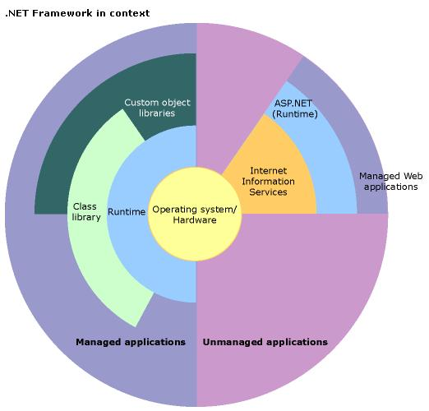
The .NET Framework has two main components: the common language runtime and the .NET Framework class library.

3.1.1 Features of the Common Language Runtime

The common language runtime is the foundation of the .NET Framework. The common language runtime manages memory, thread execution, code execution, code safety verification, compilation, and other system services. These features are intrinsic to the managed code that runs on the common language runtime. The runtime also accelerates developer productivity. For example, programmers can write applications in their development language of choice, yet take full advantage of the runtime, the class library, and components written in other languages by other developers.

3.1.2 Features of the Class Library

The .NET Framework class library is a collection of reusable types that tightly integrate with the common language runtime. The class library is object oriented, providing types from which your own managed code can derive functionality. This not only makes the .NET Framework types easy to use, but also reduces the time associated with learning new features of the .NET Framework. In addition, third-party components can integrate seamlessly with classes in the .NET Framework.

3.2 VISUAL BASIC .NET

The Microsoft Visual Basic is a Rapid Application development Tool (RAD) that is very useful for GUI based development. Visual Basic is the fastest and easiest way to create the applications for Microsoft Windows. The “Visual” part refers to the method used to create the graphical user interface (GUI). Rather than writing numerous lines of code, we can simply drag and drop built-in object onto the forms on screen. The “Basic” part refers to the BASIC (Beginners All Purpose Symbolic Code) language, used by more programmers than any other language in the history of computing. Visual Basic is evaluated from the original BASIC language and now contains several hundred statements, functions, and keywords, many of which relate directly into the Windows GUI.
Data access feature allows you to create database, front-end applications, and scalable server-side components for most popular database formats, including Microsoft SQL server and other enterprise - level database.ActiveXTM technologies allow you to use the functionality provided by the applications, such as Microsoft Word processor, Microsoft Excel spreadsheet, and other windows applications. You can even automate applications and objects created using the Professional or Enterprise editions of Visual Basic.

It has several types of primary Controls and ActiveX controls, which gives more flexibility for designing forms. It facilities to created own user define ActiveX controls for effective Design of Forms. Visual Basic supports object oriented programming. By this we can create classes, objects with all features of OOP. Like information Hiding, Data Encapsulation, Inheritance and Polymorphism. It gives more facility for the database programming with Data Controls, Data Access Objects (DAO), Remote Data Objects (RDO), and Active Data Object (ADO) and several data bound control like DBcombo, DBlist and DBgrid controls which makes application simple way to access several database through open database connectivity (ODBC).

3.4 ADO.NET

The ADO.NET components have been designed to factor data access from data manipulation. There are two central components of ADO.NET that accomplish this: the Dataset, and the .NET data provider, which is a set of components including the Connection, Command, Data Reader, and Data Adapter objects.
The ADO.NET Dataset is the core component of the disconnected architecture of ADO.NET. The Dataset is explicitly designed for data access independent of any data source. As a result it can be used with multiple and differing data sources, used with XML data, or used to manage data local to the application. The Dataset contains a collection of one or more Data Table objects made up of rows and columns of data, as well as primary key, foreign key, constraint, and relation information about the data in the Data Table objects.
The other core element of the ADO.NET architecture is the. NET data provider, whose components are explicitly designed for data manipulation and fast, forward-only, read-only access to data. The Connection object provides connectivity to a data source. The Command object enables access to database commands to return data, modify data, run stored procedures, and send or retrieve parameter information. The Data Reader provides a high-performance stream of data from the data source. Finally, the Data Adapter provides the bridge between the Dataset object and the data source. The Data Adapter uses Command objects to execute SQL commands at the data source to both load the Dataset with data, and reconcile changes made to the data in the Dataset back to the data source.

Client Application Development
Client applications are the closest to a traditional style of application in Windows-based programming. These are the types of applications that display windows or forms on the desktop, enabling a user to perform a task. Client applications include applications such as word processors and spreadsheets, as well as custom business applications such as data-entry tools, reporting tools, and so on. Client applications usually employ windows, menus, buttons, and other GUI elements, and they likely access local resources such as the file system and peripherals such as printers.
Another kind of client application is the traditional ActiveX control (now replaced by the managed Windows Forms control) deployed over the Internet as a Web page. This application is much like other client applications: it is executed natively, has access to local resources, and includes graphical elements.
In the past, developers created such applications using C/C++ in conjunction with the Microsoft Foundation Classes (MFC) or with a rapid application development (RAD) environment such as Microsoft® Visual Basic®. The .NET Framework incorporates aspects of these existing products into a single, consistent development environment that drastically simplifies the development of client applications.
The Windows Forms classes contained in the .NET Framework are designed to be used for GUI development. You can easily create command windows, buttons, menus, toolbars, and other screen elements with the flexibility necessary to accommodate shifting business needs.
For example, the .NET Framework provides simple properties to adjust visual attributes associated with forms. In some cases the underlying operating system does not support changing these attributes directly, and in these cases the .NET Framework automatically recreates the forms. This is one of many ways in which the .NET Framework integrates the developer interface, making coding simpler and more consistent.
Unlike ActiveX controls, Windows Forms controls have semi-trusted access to a user's computer. This means that binary or natively executing code can access some of the resources on the user's system (such as GUI elements and limited file access) without being able to access or compromise other resources. Because of code access security, many applications that once needed to be installed on a user's system can now be safely deployed through the Web. Your applications can implement the features of a local application while being deployed like a Web page.

4. SOFTWARE REQUIREMENT ANALYSIS

4.1PRESENT SYSTEM

DISADVANTAGES
With the present system, everything we have to do manually. Even if we appoint any new agent or staff to maintain their details bit difficult and cost wise also it’s very high. We have keep to maintain up to date details about Hotel tariff and the services provided by various hotel. To know about the hotel tariff some one should go there or to make a call to the hotel. If we change any tariff in our tour packages we have to inform all the agents threw phone calls or personally should go to each and every agent. Manual process always have the additional overheads and it includes the time factor. Dynamically we can’t do anything when we are doing manually. There is lot of misuses will happen earlier.

4.4 PROPOSED SYSTEM

The Project deals with the Tour Operators. It will use full for their transactions. Earlier they used to maintain all the tour packages, hotel details, and tariff of different types of hotels, Vehicle types and models by manually.

By using this software they made their operations very easily. Tour operators can guide their customers to take about their best tour packages. Here the tour operators will give more options to the customers to choose.

Tour Operating Companies manage their customers and provides the information about Hotels, Vehicles. It makes easy to all operations of the tour company and accurate.

Tour Operators can take different type of reports on day wise, weekly wise and monthly wise. By using these reports they can analyze their business. They can track the agent wise business reports and staff wise reports. These reports will helpful for to maintain their accounts and financial transactions.

4.5 MODULE DIVISION

Radiant Reservation System (RRS) is an integrated software deals with Tour Operating Companies. Helps the Tour Operating Companies manage their customers and provides the information about Hotels, Vehicles. It makes easy to all operations of the tour company and accurate.

Mainly it divided into five modules
(1) Admin Module,
(2) Hotel Module,
(3) Itinerary Module,
(4) Vehicle Module,
(5) MI Reports

4.5.1 ADMIN MODULE

Admin module deals with the entire Master forms. This module has the following privileges such as
- Staff Master
- Agent Master
- Activity Master
- Location Master
- User Master
- Security Access Level

Staff Master – Admin will add the staff and will provide the privileges as per the staff designation. All the staff members cannot access all the modules. He can add or delete the staff accounts.

Agent Master – Admin will add or delete the agents. Agents will get all the information about all the modules but they will have few privileges. Agents cannot modify or update the tariff of Itinerary, Vehicle and Hotel. Admin only will do all the modifications as per the requirements.

Activity Master – Admin will configure activity program. In this he will add activity provider id, activity code, activity, location, rate type, unit (Number of hours or days). Here we have two types of rates. One is rack rate and another one is corporate rate. We can take activity vouchers of particular activity.

Location Master – In this Page admin will provide the Country, City, State, Location codes. So that agents or users can access easily identify the locations by using the codes.

User Master – In this page admin will create the accounts user id, staff id and password. Here the administrator will enable or disable particular users.

Security Level – In this module administrator will take care about all the security levels like to provide the privileges to the users and agents (Which will restrict the users to access the project i.e. for some users to access the project i.e. for some users only some screens are available to work based on their permission) etc.

4.5.2 Hotel Module

This Module deals with the various hotel details. Hotel details generally we will maintain hotel master. It has all the details like Name of the hotel, hotel address, hotel type, contact person details, number of rooms in hotel and facilities available in that hotel. Here we will maintain hotel tariff according to the room type, bed type, sharing type, seasonal wise age group wise i.e. adult. Junior, child, corporate and rake rate wise. Group wise discounts will be accommodated.

In this module we will have different pages like

- Hotel Chain
- Hotel Master
- Room Category
- Hotel Season
- Hotel Surcharge
- Hotel Room Tariff
- Child Room Tariff
- Hotel Meal Tariff
- hotel Facilities
- hotel Voucher

4.5.3 Itinerary Module

Itinerary Module deals with client profile, Fixed touring packages, it schedule and custom itineraries in this reserving of hotels and vehicles etc has been handled. In this itinerary Total package price and adult price, child price breakups will come automatically. Customer master screen also included in this module. Customer contact information, group details, breakups of individual arrivals and departures in the group, customer code generation and tracking will be there. Grouping can be done customers wise, Guide and drivers allocation will be done.

In this module we will have 3 different pages like
- Client Profile
- Fixed Itineraries Booking
- Custom Itineraries Booking

4.5.4 Vehicle Module

This module deals with various types of vehicles. It has Vehicle Master it capture Vehicle details i.e. Vehicle type, vehicle own or hired, vehicle registration no, Vehicle chassis No. Insurance details standard mileage, how many seaters. Vehicle tariff for Own vehicle and Hired Vehicle based on hour wise , Km wise based on Vehicle Type. It will capture Rake rate and corporate rate. In this duty slip / vehicle allocation and bill generation also there.

In this module we will have different pages to access easily like….
- Vehicle Type
- Vehicle Master
- Vehicle Tariff
- Vehicle Allocation
- Vehicle Voucher

4.5.5 Reports Module

In this module we can generate the various MIS Reports to keep track of the revenue, customer statistics agent’s performance, month wise , during the days and year wise etc., Voucher where generated for the customer for all the accommodation and transport facilities asked by the customer.

- Activity Reports
- Admin Reports
- Customer Reports
- Hotel Reports
- Itineraries Reports
- Mailing List
- Vehicle Report

5. DATA FLOW DIAGRAM:

A data flow diagram is graphical tool used to describe and analyze movement of data through a system. These are the central tool and the basis from which the other components are developed. The transformation of data from input to output, through processed, may be described logically and independently of physical components associated with the system. These are known as the logical data flow diagrams. The physical data flow diagrams show the actual implements and movement of data between people, departments and workstations. A full description of a system actually consists of a set of data flow diagrams. Using two familiar notations Yourdon, Gane and Sarson notation develops the data flow diagrams. Each component in a DFD is labeled with a descriptive name. Process is further identified with a number that will be used for identification purpose. The development of DFD’s is done in several levels. Each process in lower level diagrams can be broken down into a more detailed DFD in the next level. The lop-level diagram is often called context diagram. It consists a single process bit, which plays vital role in studying the current system. The process in the context level diagram is exploded into other process at the first level DFD.

The idea behind the explosion of a process into more process is that understanding at one level of detail is exploded into greater detail at the next level. This is done until further explosion is necessary and an adequate amount of detail is described for analyst to understand the process.

Larry Constantine first developed the DFD as a way of expressing system requirements in a graphical from, this lead to the modular design.

A DFD is also known as a “bubble Chart” has the purpose of clarifying system requirements and identifying major transformations that will become programs in system design. So it is the starting point of the design to the lowest level of detail. A DFD consists of a series of bubbles joined by data flows in the system.

DFD SYMBOLS:

In the DFD, there are four symbols

- A square defines a source(originator) or destination of system data
- An arrow identifies data flow. It is the pipeline through which the information flows
- A circle or a bubble represents a process that transforms incoming data flow into outgoing data flows.
- An open rectangle is a data store, data at rest or a temporary repository of data

Process that transforms data flow.

Source or Destination of data

Data flow

Data Store

CONSTRUCTING A DFD:

Several rules of thumb are used in drawing DFD’s:

- Process should be named and numbered for an easy reference. Each name should be representative of the process.

- The direction of flow is from top to bottom and from left to right. Data Traditionally flow from source to the destination although they may flow back to the source. One way to indicate this is to draw long flow line back to a source. An alternative way is to repeat the source symbol as a destination. Since it is used more than once in the DFD it is marked with a short diagonal.
- When a process is exploded into lower level details, they are numbered.
- The names of data stores and destinations are written in capital letters. Process and dataflow names have the first letter of each work capitalized

A DFD typically shows the minimum contents of data store. Each data store should contain all the data elements that flow in and out.

Questionnaires should contain all the data elements that flow in and out. Missing interfaces redundancies and like is then accounted for often through interviews.

SAILENT FEATURES OF DFD’s

- The DFD shows flow of data, not of control loops and decision are controlled considerations do not appear on a DFD.

- The DFD does not indicate the time factor involved in any process whether the data flows take place daily, weekly, monthly or yearly.
- The sequence of events is not brought out on the DFD.

TYPES OF DATA FLOW DIAGRAMS
- Current Physical
- Current Logical
- New Logical
- New Physical

CURRENT PHYSICAL:

In Current Physical DFD process label include the name of people or their positions or the names of computer systems that might provide some of the overall system-processing label includes an identification of the technology used to process the data. Similarly data flows and data stores are often labels with the names of the actual physical media on which data are stored such as file folders, computer files, business forms or computer tapes.

CURRENT LOGICAL:

The physical aspects at the system are removed as mush as possible so that the current system is reduced to its essence to the data and the processors that transform them regardless of actual physical form.

NEW LOGICAL:

This is exactly like a current logical model if the user were completely happy with he user were completely happy with the functionality of the current system but had problems with how it was implemented typically through the new logical model will differ from current logical model while having additional functions, absolute function removal and inefficient flows recognized.

NEW PHYSICAL:

The new physical represents only the physical implementation of the new system.

RULES GOVERNING THE DFD’S

PROCESS
- No process can have only outputs.
- No process can have only inputs. If an object has only inputs than it must be a sink.
- A process has a verb phrase label.

DATA STORE
- Data cannot move directly from one data store to another data store, a process must move data.
- Data cannot move directly from an outside source to a data store, a process, which receives, must move data from the source and place the data into data store
- A data store has a noun phrase label.

SOURCE OR SINK
The origin and /or destination of data.

- Data cannot move direly from a source to sink it must be moved by a process
- A source and /or sink has a noun phrase land

DATA FLOW
- A Data Flow has only one direction of flow between symbol. It may flow in both directions between a process and a data store to show a read before an update. The later is usually indicated however by two separate arrows since these happen at different type.
- A join in DFD means that exactly the same data comes from any of two or more different processes data store or sink to a common location.
- A data flow cannot go directly back to the same process it leads. There must be atleast one other process that handles the data flow produce some other data flow returns the original data into the beginning process.
- A Data flow to a data store means update ( delete or change).
- A data Flow from a data store means retrieve or use.
A data flow has a noun phrase label more than one data flow noun phrase can appear on a single arrow as long as all of the flows on the same arrow move together as one package.

- About UML:

Unified Modeling Language:
The Unified Modeling Language allows the software engineer to express an analysis model using the modeling notation that is governed by a set of syntactic semantic and pragmatic rules.

A UML system is represented using five different views that describe the system from distinctly different perspective. Each view is defined by a set of diagram, which is as follows.
  - User Model View
    - This view represents the system from the users perspective.
    - The analysis representation describes a usage scenario from the end-users perspective.

  - Structural model view
    - In this model the data and functionality are arrived from inside the system.
    - This model view models the static structures.

- Behavioral Model View
It represents the dynamic of behavioral as parts of the system, depicting the interactions of collection between various structural elements described in the user model and structural model view.

- Implementation Model View
In this the structural and behavioral as parts of the system are represented as they are to be built.

- Environmental Model View
In this the structural and behavioral aspects of the environment in which the system is to be implemented are represented.

UML is specifically constructed through two different domains they are:
- UML Analysis modeling, this focuses on the user model and structural model views of the system.
- UML design modeling, which focuses on the behavioral modeling, implementation modeling and environmental model views.

Use case Diagrams represent the functionality of the system from a user’s point of view. Use cases are used during requirements elicitation and analysis to represent the functionality of the system. Use cases focus on the behavior of the system from external point of view.

Actors are external entities that interact with the system. Examples of actors include users like administrator, bank customer …etc., or another system like central database.

Use case Diagrams
- Use case diagrams describe what a system does from the standpoint of an external observer. The emphasis is on what a system does rather than how.
- Use case diagrams are closely connected to scenarios. A scenario is an example of what happens when someone interacts with the system.
- A use case is a summary of scenarios for a single task or goal. An actor is who or what initiates the events involved in that task. Actors are simply roles that people or objects play.
- A use case diagram is a collection of actors, use cases, and their communications.
Use case diagrams are helpful in three areas:
- Determining features (requirements). New use cases often generate new requirements as the system is analyzed and the design takes shape.
- Communicating with clients. Their notational simplicity makes use case diagrams a good way for developers to communicate with clients.
- Generating test cases. The collection of scenarios for a use case may suggest a suite of test cases for those scenarios.

Class Diagrams
- A Class diagram gives an overview of a system by showing its classes and the relationships among them.
- Class diagrams are static. They display what interacts but not what happens when they do interact.
Notations:
- UML class notation is a rectangle divided into three parts: class name, attributes, and operations.
- Names of abstract classes are in italics. [example: Payment]
- Relationships between classes are the connecting links.

Relationships:
- Association -- a relationship between instances of the two classes. There is an association between two classes if an instance of one class must know about the other in order to perform its work. In a diagram, an association is a link connecting two classes.
- Aggregation -- an association in which one class belongs to a collection. An aggregation has a diamond end pointing to the part containing the whole. In our diagram, Order has a collection of OrderDetails.
- Generalization -- an inheritance link indicating one class is a superclass of the other. A generalization has a triangle pointing to the super class. Payment is a super class of Cash, Check, and Credit.
- Composition -- Each instance of type Circle seems to contain an instance of type Point. Composition relationships are a strong form of containment or aggregation. Aggregation is a whole/part relationship. Composition also indicates that the lifetime of Point is dependent upon Circle. This means that if Circle is destroyed, Point will be destroyed with it.
- An association has two ends. An end may have a role name to clarify the nature of the association. For example, an OrderDetail is a line item of each Order.
- A navigability arrow on an association shows which direction the association can be traversed or queried. An OrderDetail can be queried about its Item, but not the other way around. The arrow also lets you know who "owns" the association's implementation; in this case, OrderDetail has an Item. Associations with no navigability arrows are bi-directional.
- The multiplicity of an association end is the number of possible instances of the class associated with a single instance of the other end. Multiplicities are single numbers or ranges of numbers. In our example, there can be only one Customer for each Order, but a Customer can have any number of Orders.
- Every class diagram has classes, associations, and multiplicities. Navigability and roles are optional items placed in a diagram to provide clarity.
- Packages appear as rectangles with small tabs at the top. The package name is on the tab or inside the rectangle.
- The dotted arrows are dependencies. One package depends on another if changes in the other could possibly force changes in the first.

Object Diagrams
- Object diagrams show instances instead of classes.
- They are useful for explaining small pieces with complicated relationships, especially recursive relationships.
- Each rectangle in the object diagram corresponds to a single instance. Instance names are underlined in UML diagrams. Class or instance names may be omitted from object diagrams as long as the diagram meaning is still clear.

Sequence Diagrams
- Class and object diagrams are static model views. Interaction diagrams are dynamic. They describe how objects collaborate.
- A sequence diagram is an interaction diagram that details how operations are carried out -- what messages are sent and when.
- Sequence diagrams are organized according to time. The time progresses as you go down the page.
- The objects involved in the operation are listed from left to right according to when they take part in the message sequence.

Collaboration Diagrams
- Collaboration diagrams are also interaction diagrams.
- They convey the same information as sequence diagrams, but they focus on object roles instead of the times that messages are sent.
- In a sequence diagram, object roles are the vertices and messages are the connecting links.

Notations:
- The object-role rectangles are labeled with either class or object names (or both). Class names are preceded by colons ( : ).
- Each message in a collaboration diagram has a sequence number. The top-level message is numbered 1. Messages at the same level (sent during the same call) have the same decimal prefix but suffixes of 1, 2, etc. according to when they occur.

Statechart Diagrams
- Objects have behaviors and state. The state of an object depends on its current activity or condition.
- A statechart diagram shows the possible states of the object and the transitions that cause a change in state.
- This diagram has two self-transition, one on Getting SSN and another on Getting PIN.
- While in its Validating state, the object does not wait for an outside event to trigger a transition. Instead, it performs an activity. The result of that activity determines its subsequent state.
Notations
- States are rounded rectangles.
- Transitions are arrows from one state to another. Events or conditions that trigger transitions are written beside the arrows.
- The initial state (black circle) is a dummy to start the action. Final states are also dummy states that terminate the action.
- The action that occurs as a result of an event or condition is expressed in the form /action.

Activity Diagrams
- An activity diagram is essentially a fancy flowchart. Activity diagrams and statechart diagrams are related.
- While a statechart diagram focuses attention on an object undergoing a process (or on a process as an object), an activity diagram focuses on the flow of activities involved in a single process.
- The activity diagram shows the how those activities depend on one another.
Notations:
- The process begins at the black start circle at the top and ends at the concentric white/black stop circles at the bottom. The activities are rounded rectangles.
- Activity diagrams can be divided into object swimlanes that determine which object is responsible for which activity. A single transition comes out of each activity, connecting it to the next activity.
- A transition may branch into two or more mutually exclusive transitions. Guard expressions (inside [ ]) label the transitions coming out of a branch. A branch and its subsequent merge marking the end of the branch appear in the diagram as hollow diamonds.
- A transition may fork into two or more parallel activities. The fork an
- The subsequent join of the threads coming out of the fork appear in the diagram as solid bars.

Component & Deployment Diagrams

- A component is a code module. Component diagrams are physical analogs of class diagram. Deployment diagrams show the physical configurations of software and hardware.
Notations:
- The physical hardware is made up of nodes. Each component belongs on a node. Components are shown as rectangles with two tabs at the upper left.

A system is simply a set of components that interact to accomplish some purpose.
Systems are of two types.
- Open Systems.
- Closed Systems.

Systems that interact with their environments are open systems. They receive input and produce output. In contrast; systems that do not interact with their surroundings are
closed systems all ongoing systems are open. Closed systems exist only as a concept.

System development can generally be thought of as having two major components
- System Analysis.
- System Design.

System analysis is the process of gathering and interpreting facts, diagnosing problems, and using the information to recommend improvements to the system. System Design is the process of planning a new business system or one to replace or complement an existing system.

Systems analysis is about understanding situations, not solving problems. Effective analysts therefore emphasize investigation and questioning to learn how the system currently operates and to identify the requirements users have for a new or modified one. Only after analysts fully understand the system are they able to analyze it and assemble recommendations for system design.

The manner in which a systems investigation is conducted will determine whether the appropriate information is gathered. In turn, having the right information influences the quality of the application that follows .in other words, good system design, whether developed through the SDLC method, prototyping, or structured methods, begins by documenting the current system and proper diagnosing the systems requirements.

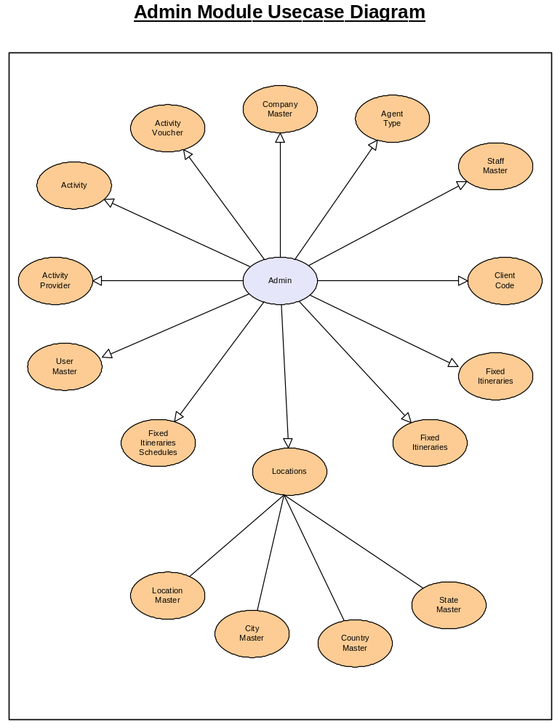

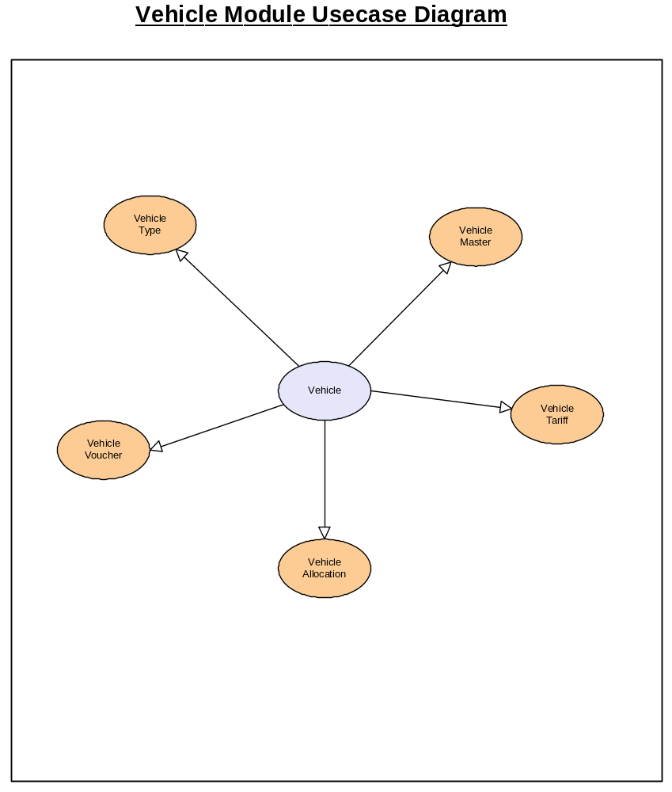

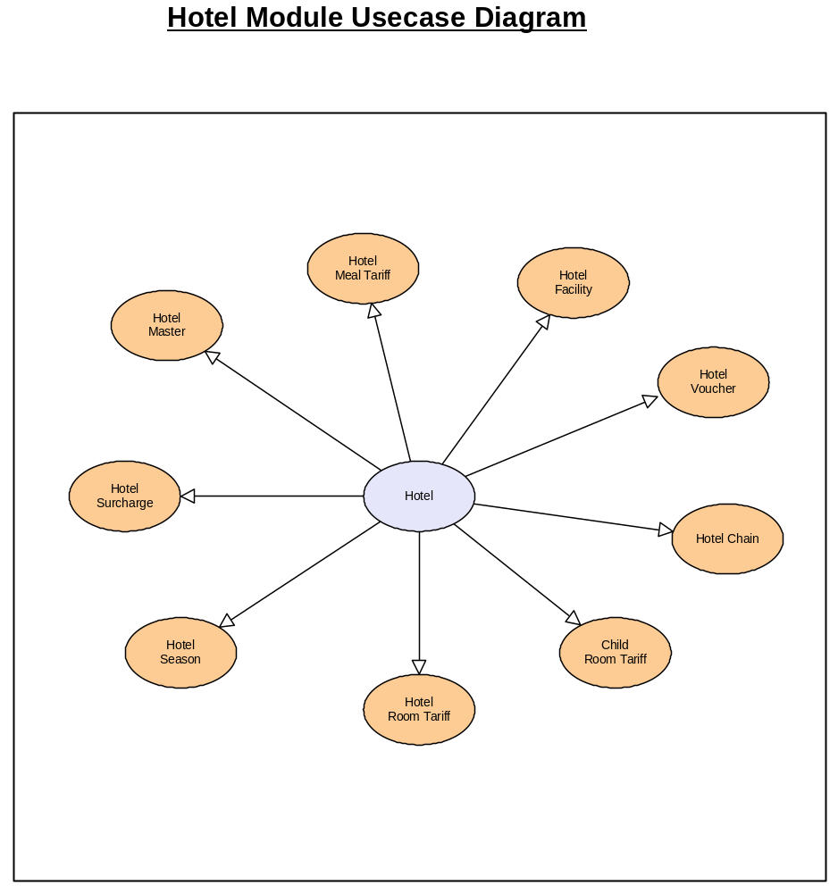

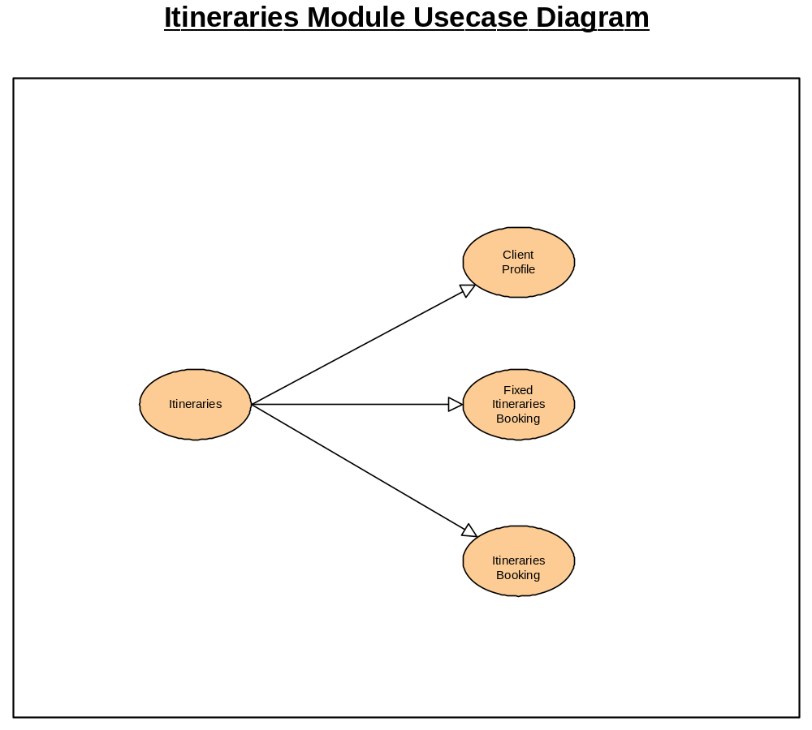

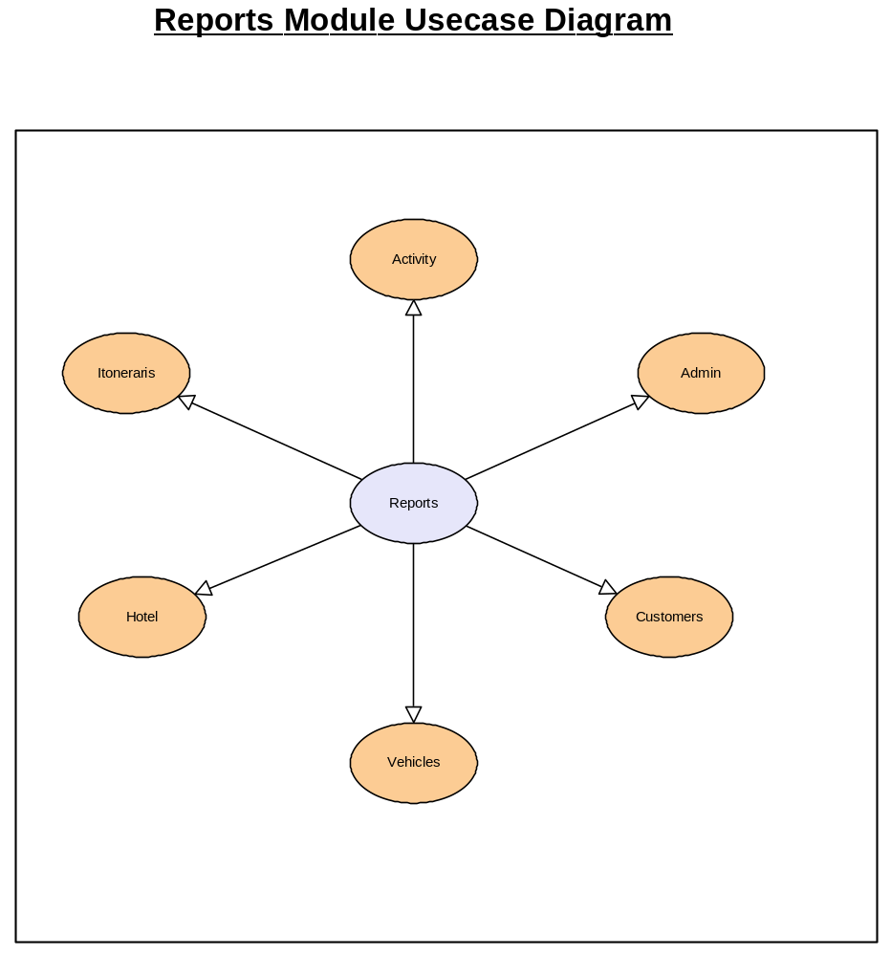
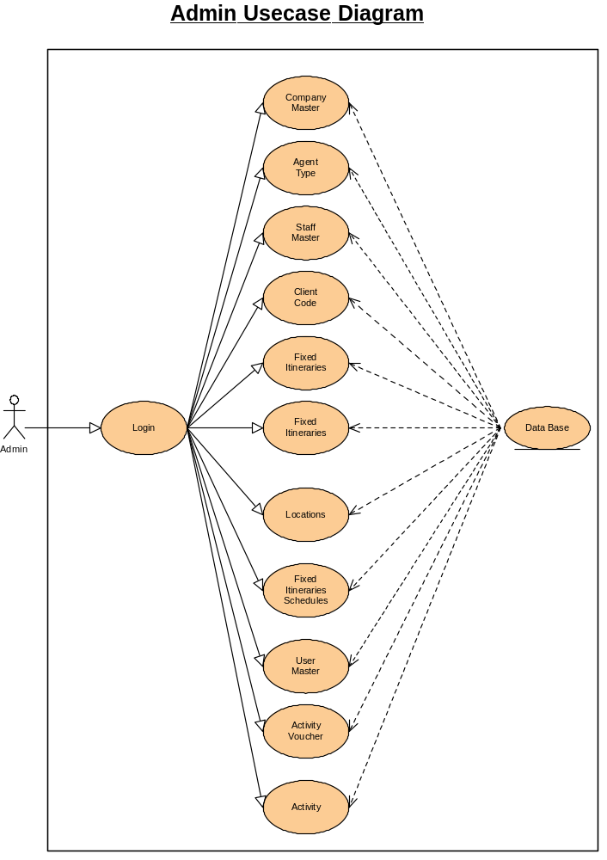

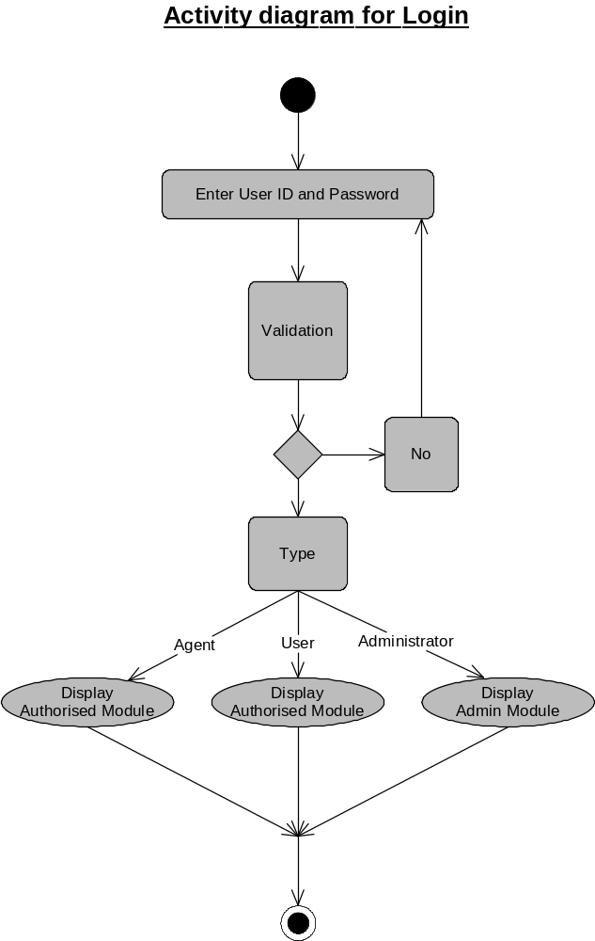
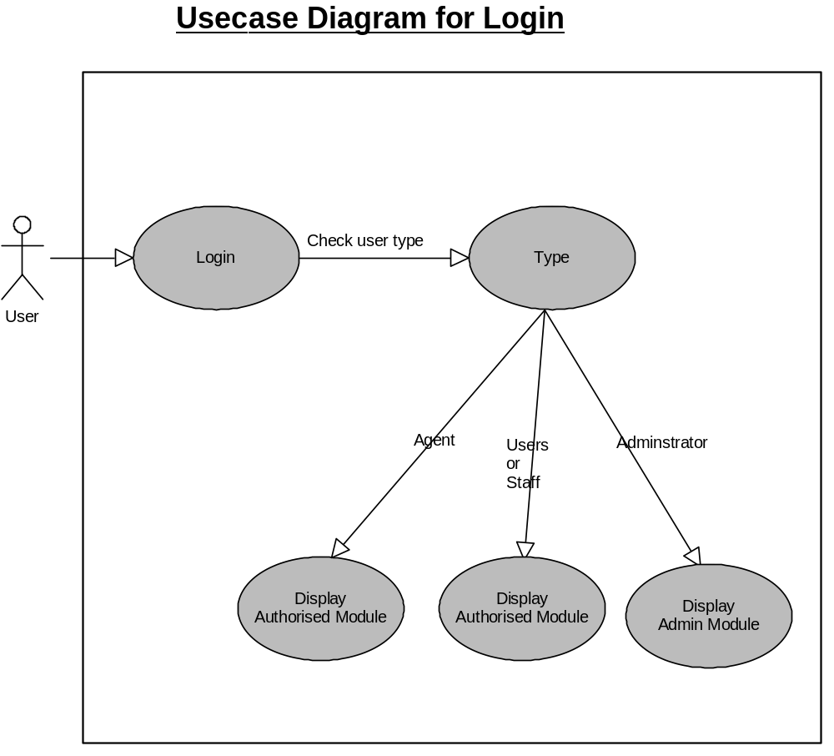

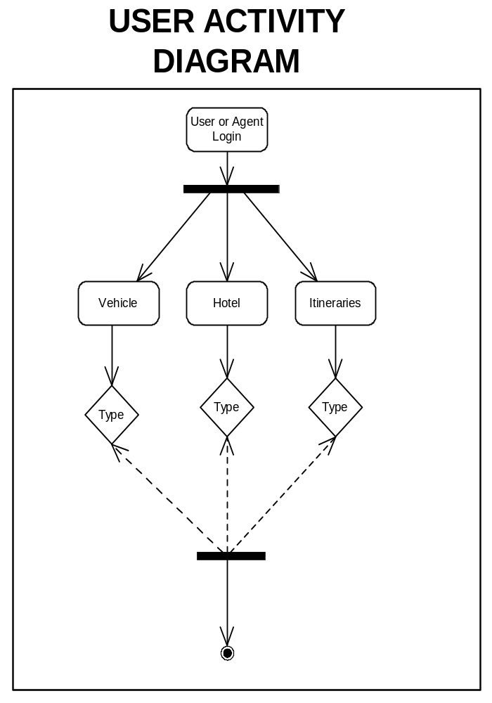

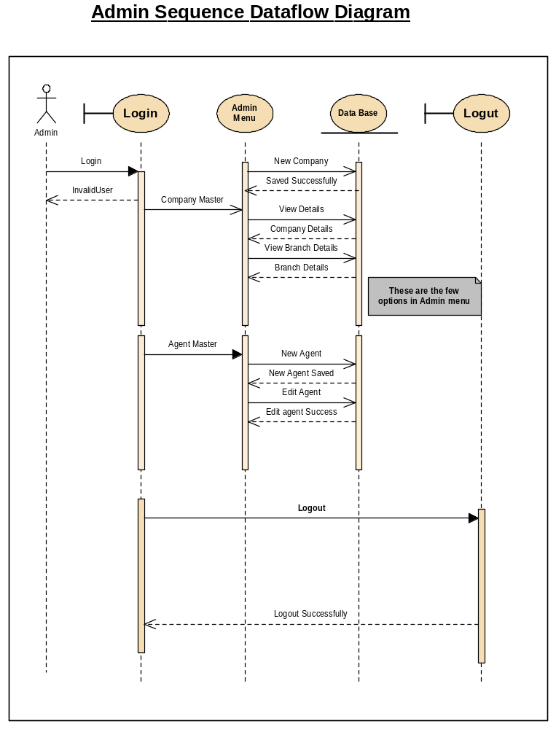

- IMPLEMENTAION

Implementation is the process of having systems personnel check out and put new equipment into use, train users, install the new application depending on the size of the organization that will be involved in using the application and the risk associated with its use, systems developers may choose to test the operation in only one area of the firm, say in one department or with only one or two persons. Sometimes they will run the old and new systems together to compare the results. In still other situation, developers will stop using the old system one-day and begin using the new one the next. As we will see, each implementation strategy has its merits, depending on the business situation in which it is considered. Regardless of the implementation strategy used, developers strive to ensure that the system’s initial use in trouble-free.

Once installed, applications are often used for many years. However, both the organization and the users will change, and the environment will be different over weeks and months. Therefore, the application will undoubtedly have to be maintained; modifications and changes will be made to the software, files, or procedures to meet emerging user requirements. Since organization systems and the business environment undergo continual change, the information systems should keep pace. In this sense, implementation is ongoing process.

Evaluation of the system is performed to identify its strengths and weakness. The actual evaluation can occur along any of the following dimensions.

Operational Evaluation: assessment of the manner in which the system functions, including ease of use, response time, suitability of information formats, overall reliability, and level of utilization.

Organization Impact: Identification and measurement of benefits to the organization in such areas as financial concerns operational efficiency, and competitive impact. Includes impact on internal and external information flows.

User Manager Assessment: Evaluation of the attitudes of senior and user mangers within the organization, as well as end-users.

Development Performance: Evaluation of the development process in accordance with such yardsticks as overall development time and effort, conformance to budgets and standards, and other project management criteria. Includes assessment of development methods and tools.

Unfortunately system evaluation does not always receive the attention it merits. Where properly managed however, it provides a great deal of information that can improve the effectiveness of subsequent application efforts.
System Implementation is used to bring a developed system or sub system into operational use and turning it over to the user. It involves programmer, users and operational management. It also needs to introduce and train the people to work with the new system.

7.TESTING

black box testing

In clearing house across various modules this testing was performed to check the following.

- Establishing communication with the database for handling request and response.
- Verification of OLE-DB providers(ADO) in functionality
- Parameters passing and report generation used from the application with crystal report.

White box testing

All the statements included in the code across various modules were tested to find none of the statements where overlooked or skipped from execution. This enabled isolating of errors that would have otherwise occurred and would have resulted in abnormal terminal or exceptions thrown. The test was corely tested in patient and responsibility, Insured party, ailments, procedures and applied payment modules.

STRING TESTING

The applications was tested for inputs pertaining to patient data, responsible party, insured party for strings such as name, relation, employ information, policy details, insurance company details, claim centre information and attorney data physician, reference physician information were tested for the following
a. null data
b. string length
c. data format
d. alpha numeric characters

In addition, numeric inputs were tested for invalid characters, invalid data format, size of the input data and the data type being handled.

UNIT TESTING

Module pertaining to patient, responsible party, and soon were tested individually to check if the system performed the business logic or processors for the inputs provided and effective communication with the data base, the units were tested to check whether the data were reflected and updated across other tables that were used by other modules. The core modules
1. Responsible party and patient
2. Insured party
3. Ailments
4. Procedures
5. Applied payments

Were tested for the availability of data from other modules.
All the units were found to execute independently and had appropriate communication with the data base. Dependent modules were tested with static data and were found to execute as per SRS.

INTEGRATED TESTING

All the units were combined from a menu driven application which then provided for integration with other modules the following well tested.
1. Message passing and communication between the modules
2. Data usage and synchronization
3. Flow of control using top-down testing confirming appropriate return of control as well as associated usability features.
SYSTEM TESTING

The system as a whole along with required external resources was executed to check the dependencies, exception across the unavailability of the resources pertaining to the network connection, OLEDB providers, authentication of database and database it self.
DSN less connection and its effective communication for database was found to be as per their SRS.

MUTATION TESTING

All fields across every module were tested rigorously with inputs that were intentionally provided with wrong data. This testing resolves bugs and errors through exception handling. That was a result of any kind of invalid data.

OUT PUT SCREEN SHOTS

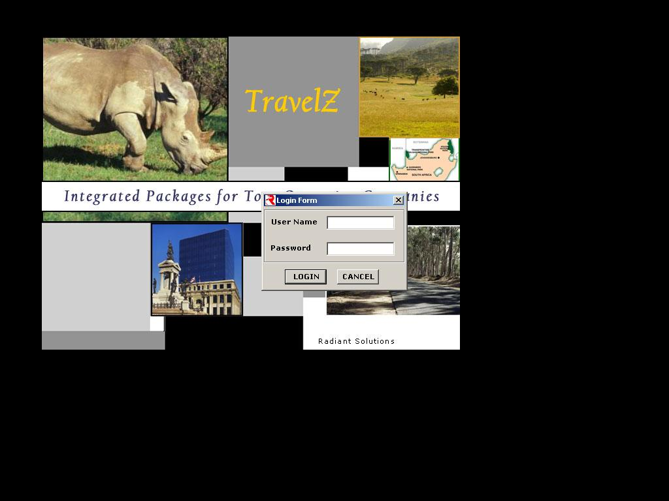

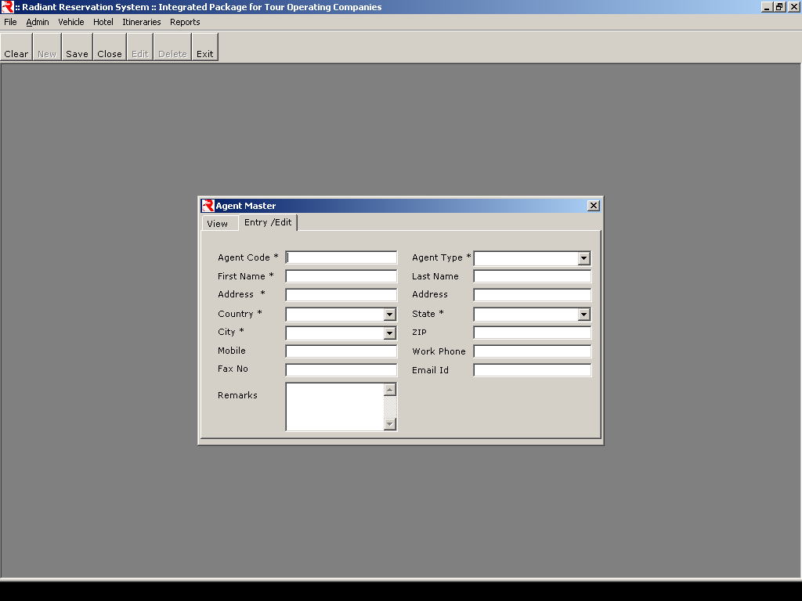

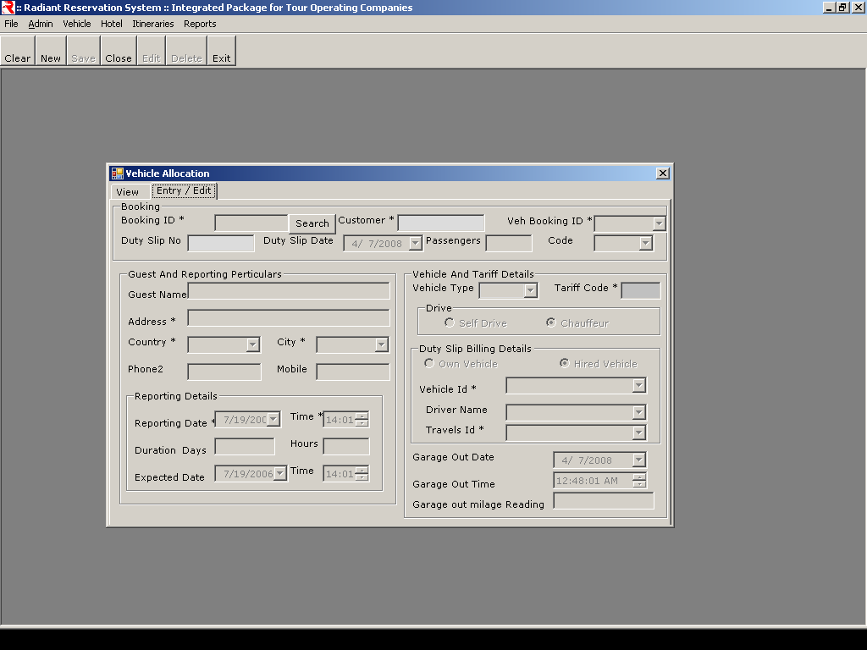

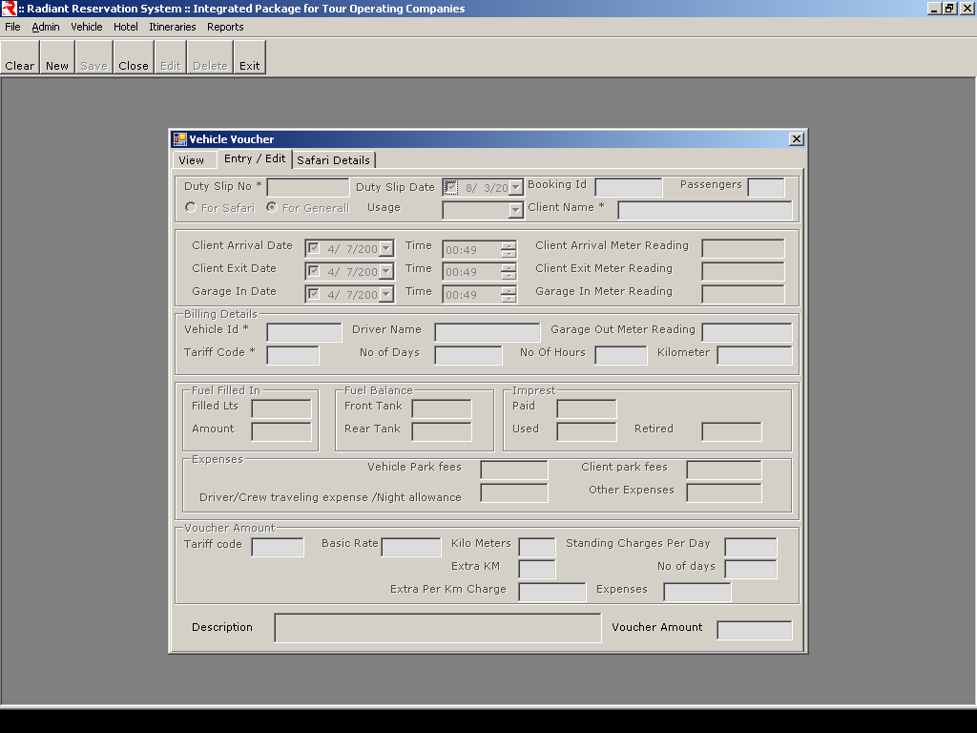

9.CONCLUSION

The scope of the project has been described and can be extended to give flexibility of performing the maintenance of the client tour details and calculating the bill after choosing tour packages.

10. FUTURE ENHANCEMENTS

This project can be further enhanced to provide greater flexibility and
performance with certain modifications whenever necessary.

11. BIBILIOGRAPHY

1. Visual Studio 2005 Black Book - Rob Thayer
5. Mastering Database Programming with Visual Basic 6 - Evangelos Petroutsos
6. Software Engineering - Pressman
7. System Analysis and Design - James A.Senn
8. An Introduction to Database Management System - C.J.Date
9. ORACLE Administration - Manual, Oracle Press
10. ORACLE SQL Reference Manual - Manual, Oracle Press

